[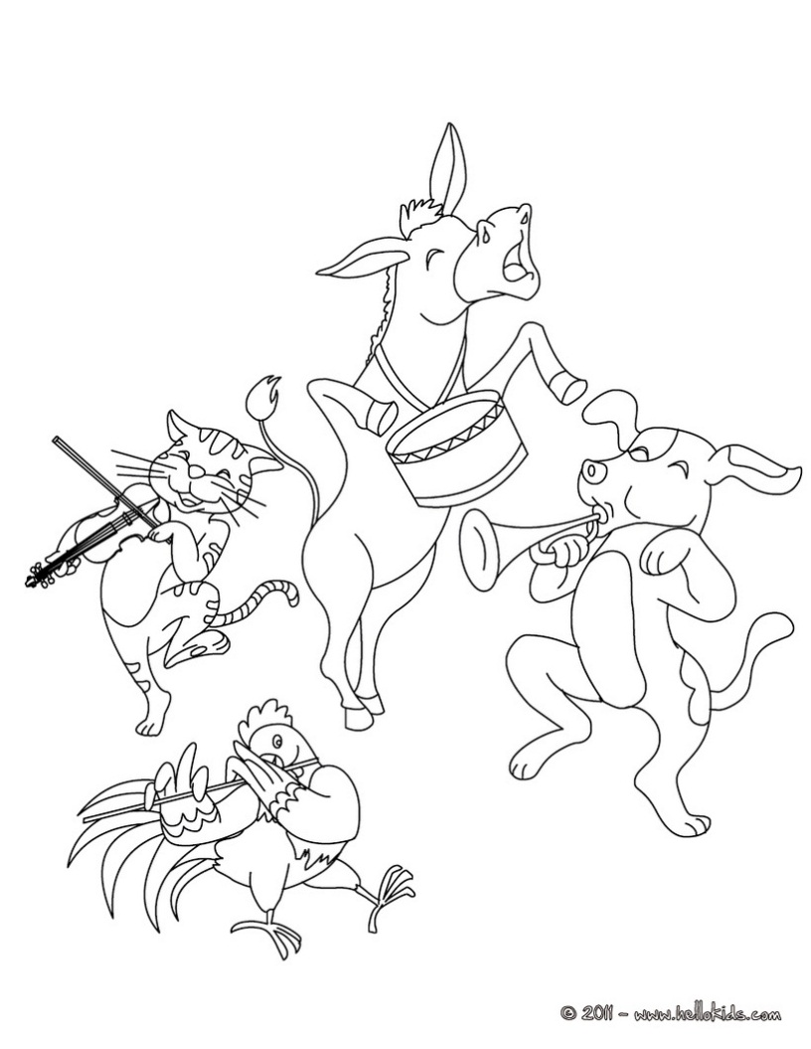](http://www.google.ro/url?sa=i&rct=j&q=&esrc=s&frm=1&source=images&cd=&cad=rja&docid=TFQ8m0YC0fPmPM&tbnid=qnfQbcXcsSgP7M:&ved=0CAUQjRw&url=http://de.hellokids.com/c_26519/ausmalbilder/marchen-zum-ausmalen/grimm-marchen-zum-ausmalen/der-kleine-daumling-marchen-zum-ausmalen&ei=2gVLUvm3Eq2b0wWO4YDgBA&bvm=bv.53371865,d.Yms&psig=AFQjCNG6qwsdTMu7wyx1j2YGC_0USeQMsw&ust=1380734798990720)