My food (Mancarea mea)

Listen and say./Asculati si spuneti:
https://www.youtube.com/watch?v=MBfrOH4eeg0

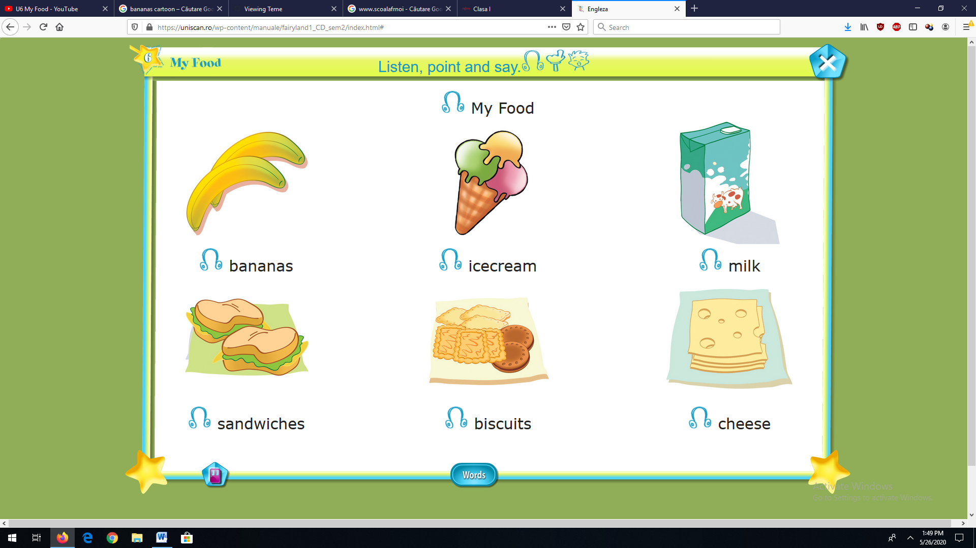
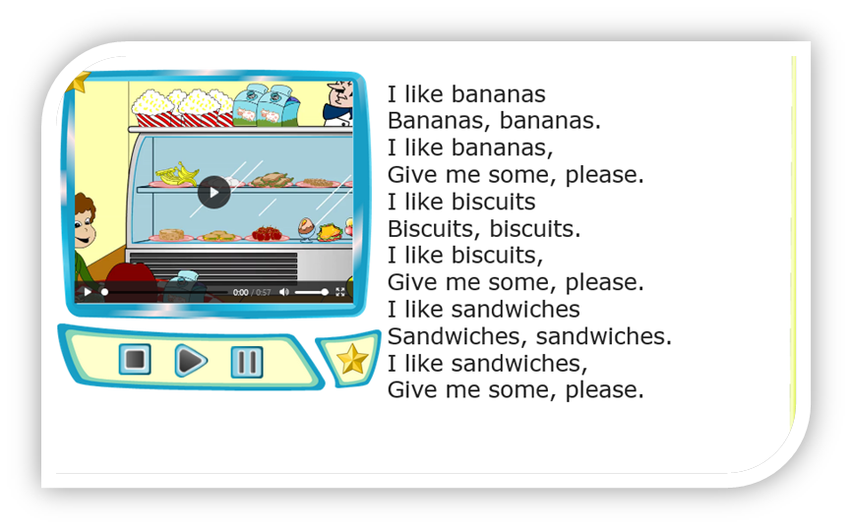

I like = Imi place
Give me some, please= Dati-mi , va rog!

