My house (Casa mea)
I.Listen and repeat/Ascultati si repetati:
https://www.youtube.com/watch?v=mTSUSkSgvE4
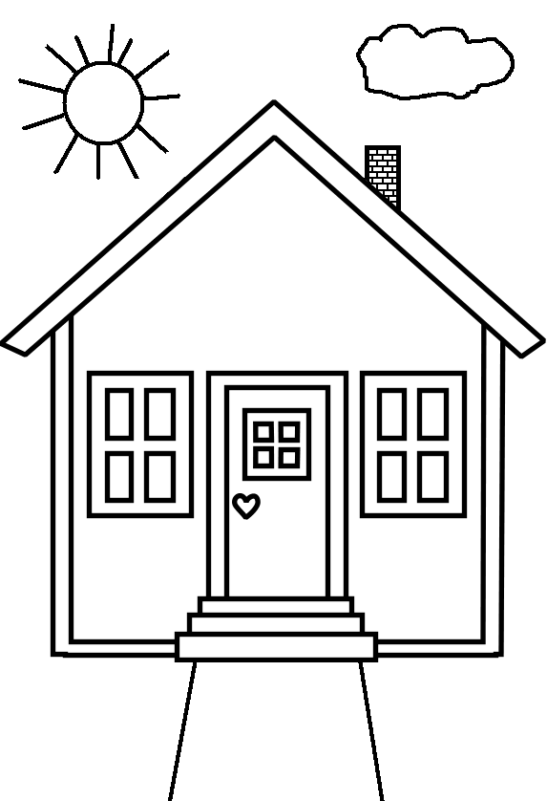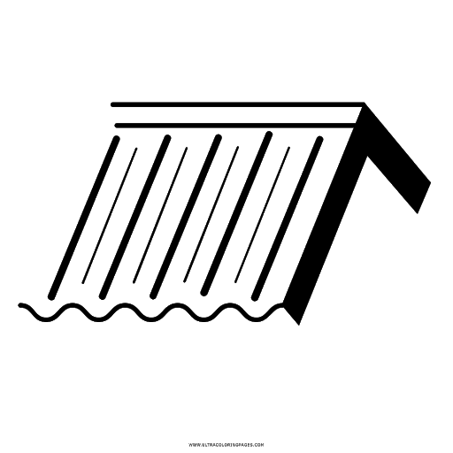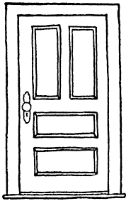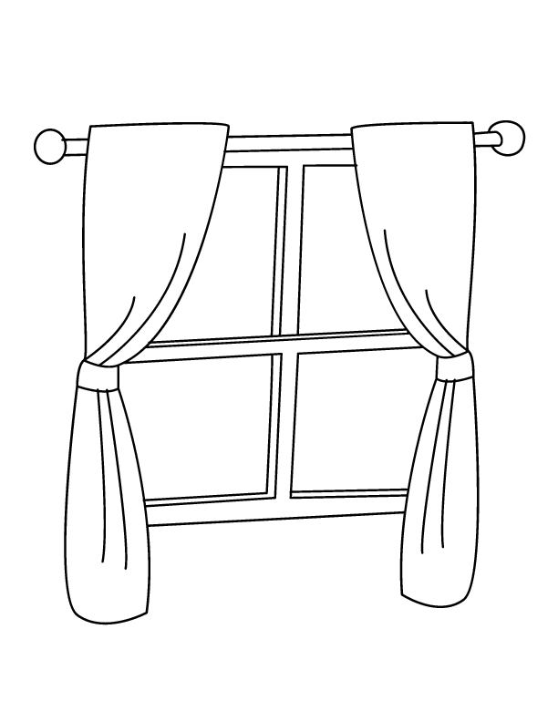
house roof door window

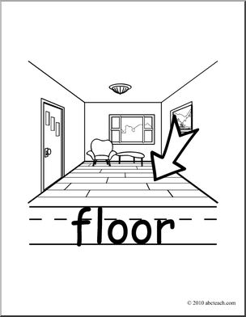
floor (se pronunta ca si door cu “o”)
II. Draw your house./Desenati casa voastra

