It’s my birthday! (Este ziua mea)

- Listen to the song and sing: Ascultati si cantati!
https://www.youtube.com/watch?v=q2ib7X7XMOU
Happy birthday! La multi ani!
Birthday=zi de nastere
- Read and repeat:
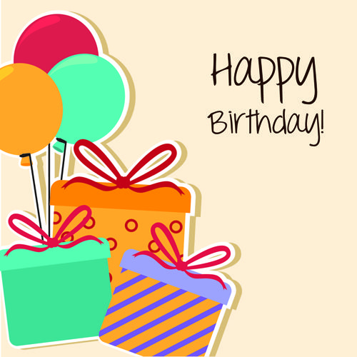
birthday card cake present

- Make a birthday card. Faceti o felicitare de ziua cuiva. Scrieti: Happy birthday ! From …./La multi ani! De la………… (numele vostru)!

