My food
Vocabulary
Apple=mar
Egg=ou
Milk=lapte

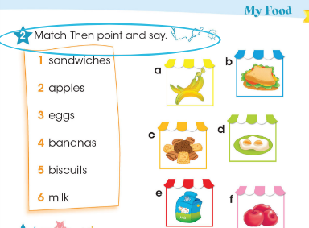
Asociati numerele cu literele potrivite.
Listen to the song:
https://www.youtube.com/watch?v=frN3nvhIHUk

