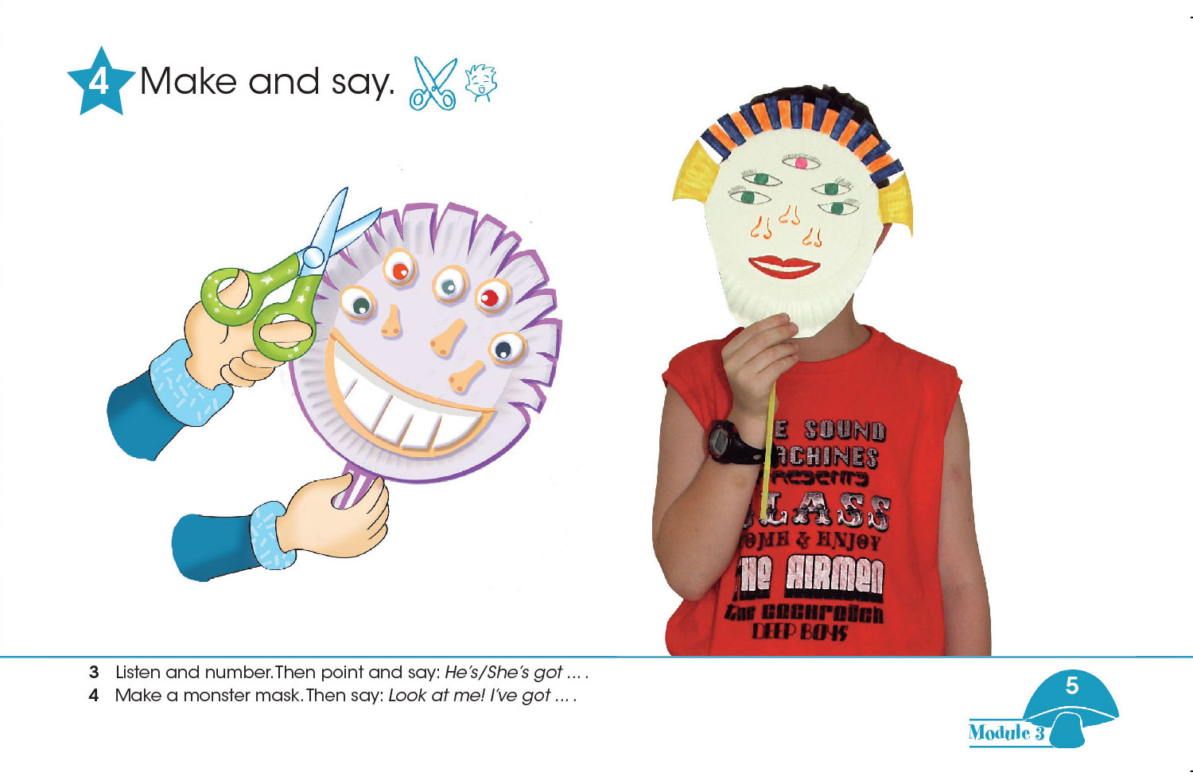
I.Draw, color and cut/ Desenati , colorati si decupati.
II. Say/Spuneți : Look at me!(Uita-te la mine!) I’ve got….(Eu am…)

