Pets/Animale de companie

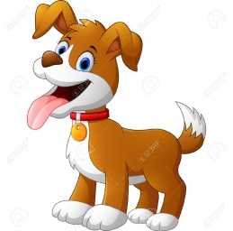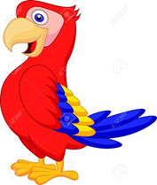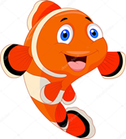
DOG PARROT /BIRD CAT FISH

- Listen to the song and sing./Ascultati cantecelul si cantati https://www.youtube.com/watch?v=pWepfJ-8XU0

- Draw your pet. Write his/her name./Desenati animalul vostru de companie. Scrieti numele lui/ei.

