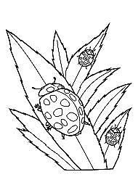

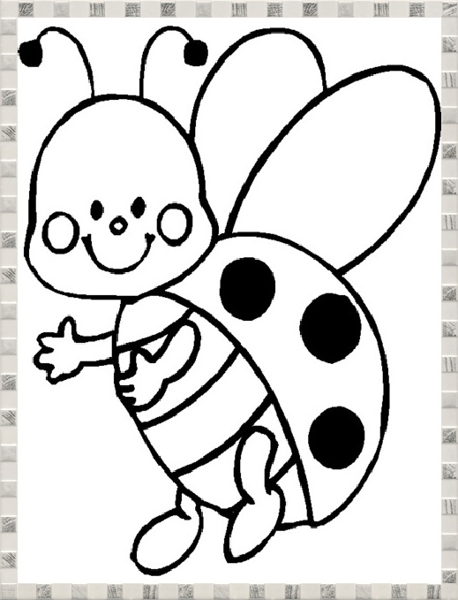

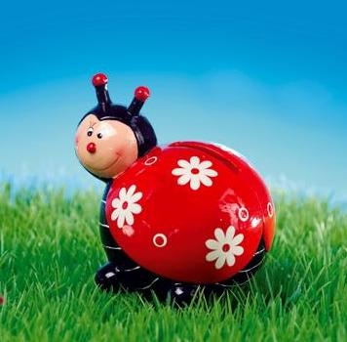



***Scrie însuşiri pentru fiecare*** *:*

primăvară ____________

ghiocei _______________

toporaşi ______________

brânduşe _____________

frunza ________________

________________

soarele _______________

păsări ________________

buburuză _____________

_____________

_____________

***Scrie care sunt semnele sosirii primăverii*** *:*

*________________________________________________________________________________________________________________________________________________________________________________________________________________________________________*

***Scrie ce face fiecare vieţuitoare :***

________________________________________________________________________________________________________________________________________________________________________________________________________________________________________________

***Învățătura textului este că_****___________________________________________________________________________________________________________________________________________________________________________________________________*

***Desparte în silabe și încercuiește cu roșu vocalele și cu verde consoanele:***

crâng___________________________________ primăvară____________________________________________________ băiețel__________________________________ gâză____________________________________________________________

**BUBURUZA**

**după Eugen Jianu**

***Scrie antonimele cuvintelor :***

albi - ___________________

cald - ___________________

lucioasă - ________________

plin - ___________________

afară - __________________

s-a întristat - _____________

prima - __________________

neînsemnată-______________

***Scrie sinonimele cuvintelor :***

veselă = _________________

s-a ivit = _________________

crâng = __________________

larmă = __________________

pajişte = _________________

copac = __________________