Actions
- Listen and repeat. /Ascultati si repetati:

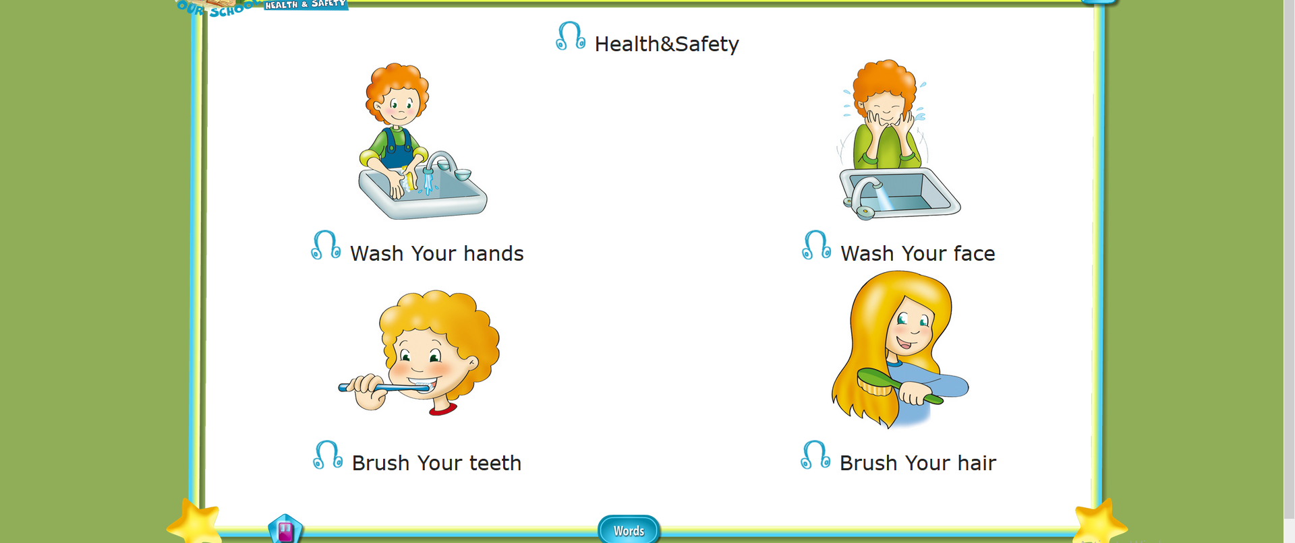
- Look and say/ Priviti si spuneti:

Woody, wash your hair!
Woody, wash your face!
Woody, wash your hands!
Woody, brush your teeth!
Woody , brush your hair!
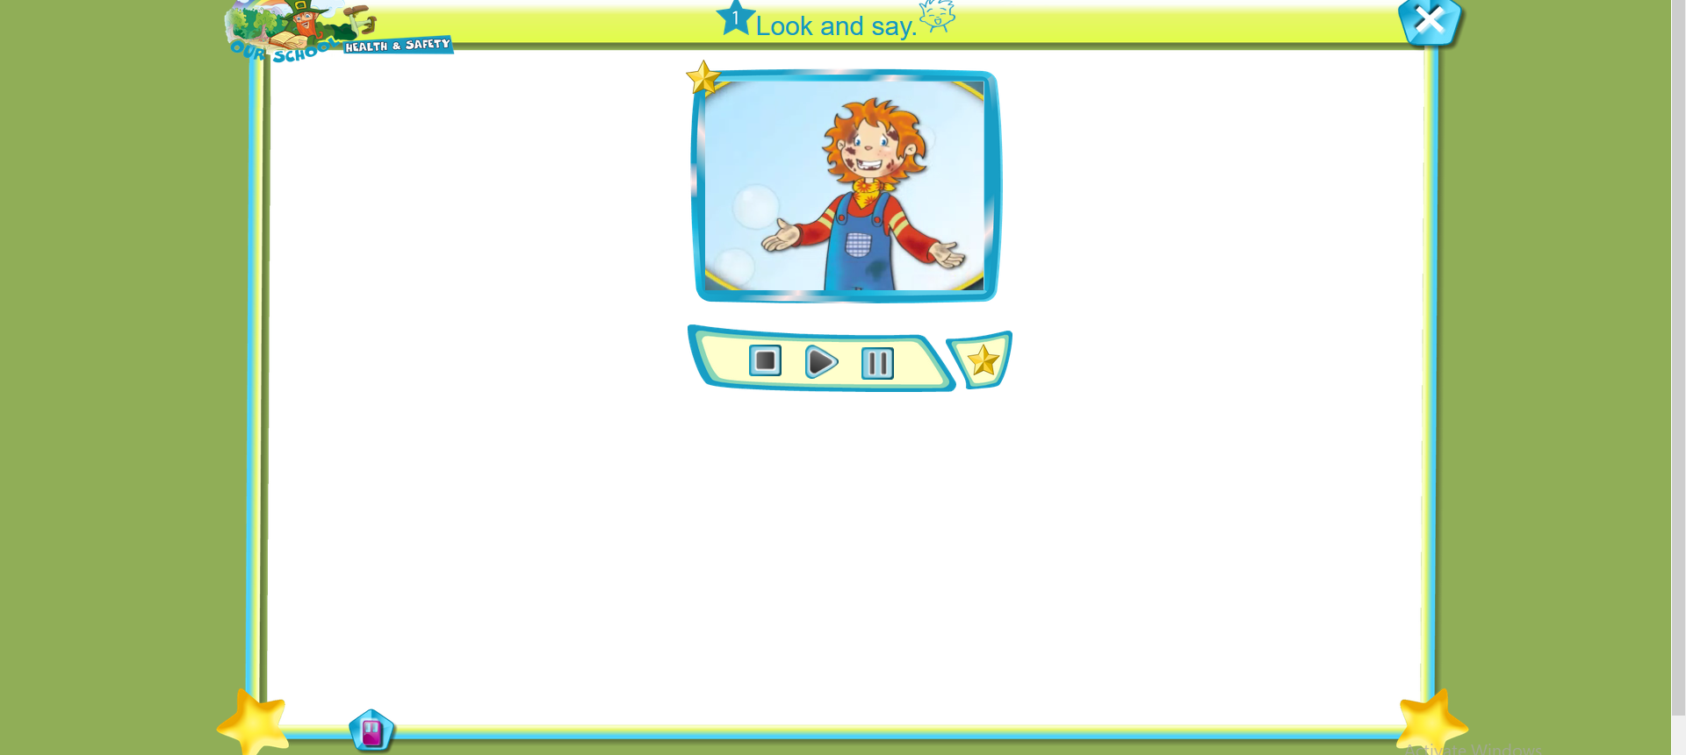

- Sing/Cantati:

